Theme | Question the theme answers | Important details | Example
Location | Where is it? | Absolute vs. Relative | Latitude/Longitude  Street Address

- Use the circle below to answer letters a-d.
  - On the circle below, draw the equator and label it 0°.
  - Draw the prime meridian and label it 0°.
  - Is the equator a line of latitude or longitude? Write your answer by the equator.
  - Is the prime meridian a line of latitude or longitude? Write your answer by the prime meridian.

- Use the circles below to answer letters a-c.

N
E
W

S

- (30°S, 60°E)
  - Which of these is the latitude coordinate?
  - Which of these is the longitude coordinate?
  - Which number do you look to the side for?
  - Which number do you look at the top/bottom for?

- Use your map of Africa to answer the questions below.
  - What COUNTRY is located at (30°N, 0° (The Prime Meridian))?
  - What COUNTRY is located at (20°N, 4°W)?
  - What COUNTRY is located at (33°S, 20°E)?
  - What COUNTRY is located at (22°N, 7°E)?
  - What CITY is located at (22°S, 17°E)?

- On the map below, label each of the following things:

Title
Key
Scale Bar
Compass Rose
Boundary Lines
Cities vs. Capitals(National)

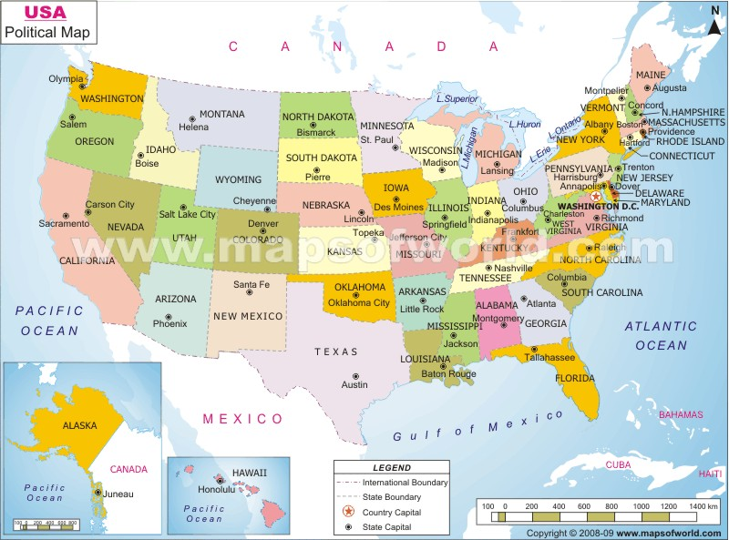

- Which of these maps is large scale and which is small scale? How do you know? Define Each.

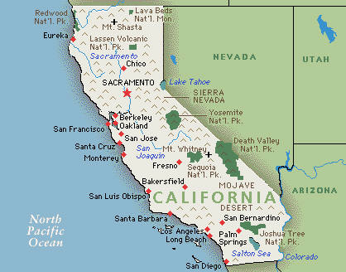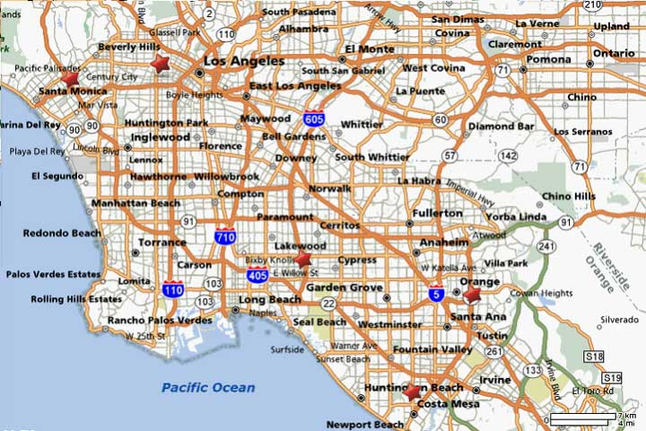

- Define the terms below and draw a picture of them.
Basin
Island
Ocean
Isthmus
Cape
Mountain
Canyon
Peninsula
Valley
Channel

